Proposed methodology
According to the facts, training and testing of DL-CNN involves in allowing every source image via a succession of convolution layers by a kernel or filter, rectified linear unit (ReLU), max pooling, fully connected layer and utilize SoftMax layer with classification layer to categorize the objects with probabilistic values ranging from $\left[0,1\right]$. Figure 1 discloses the architecture of DL-CNN that is utilized in proposed methodology for skin cancer detection and classification system for enhanced feature representation of dermoscopic image over conventional detection systems.
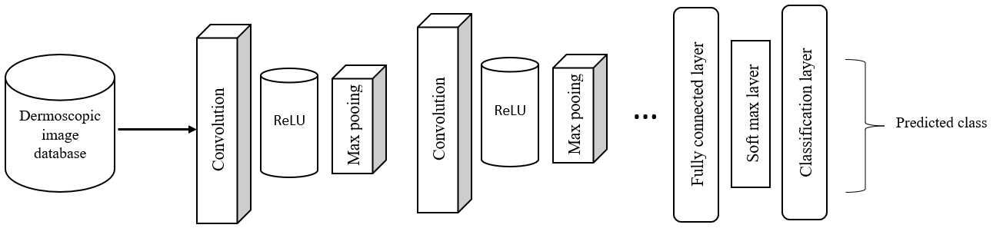
Fig. 1: CNN architecture for proposed skin cancer detection and multi-class classification.
Convolution layer as depicted in Figure 2 is the primary layer to extract the features from a source image and maintains the relationship between pixels by learning the features of image by employing tiny blocks of source data. It’s a mathematical function which considers two inputs like source image $I\left(x,y,d\right)$ where $x$ and $y$ denotes the spatial coordinates i.e., number of rows and columns. $d$ is denoted as dimension of an image (here $d=3$, since the source image is RGB) and a filter or kernel with similar size of input image and can be denoted as $F\left(k_{x},k_{y},d\right)$.
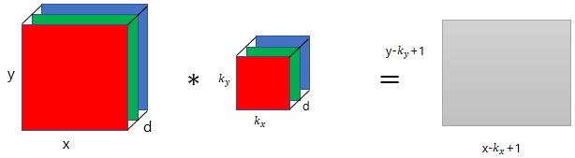
Fig. 2 Representation of convolution layer process.
The output obtained from convolution process of input image and filter has a size of $C\left(\left(x-k_{x}+1\right),\left( y-k_{y}+1\right),1\right)$, which is referred as feature map. An example of convolution procedure is demonstrated in Figure 3. Let us assume an input image with a size of $5×5$ and the filter having the size of $3×3$. The feature map of input image is obtained by multiplying the input image values with the filter values as given in Figure 3.
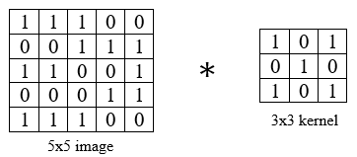
(a)
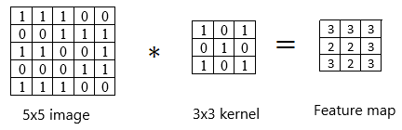
(b)
Fig. 3 Example of convolution layer process (a) an image with size $5×5$ is convolving with $3×3$ kernel (b) Convolved feature map

ReLU layer
Networks those utilizes the rectifier operation for the hidden layers are cited as rectified linear unit (ReLU). This ReLU function $G(∙)$ is a simple computation that returns the value given as input directly if the value of input is greater than zero else returns zero. This can be represented as mathematically using the function $max(∙)$ over the set of $0$ and the input $x$ as follows:
$$G\left(x\right)=\max\left\{0,x\right\}$$

Max pooing layer
This layer mitigates the number of parameters when there are larger size images. This can be called as subsampling or down sampling that mitigates the dimensionality of every feature map by preserving the important information. Max pooling considers the maximum element form the rectified feature map.

